

Windows Workflow Foundation

Hands-On Lab

Lab Manual
Lab 05 – Communicating with the Workflow Host Application (Visual Basic 2005)

Converted from C# to Visual Basic.NET courtesy of:

Serge Luca – MVP – serge@u2u.be
U2U Training and Consultancy Services is a Microsoft .NET competence center located in Belgium, to learn more please visit www.u2u.be

Information in this document, including URL and other Internet Web site references, is subject to change without notice. This document supports a preliminary release of software that may be changed substantially prior to final commercial release, and is the proprietary information of Microsoft Corporation.

This document is for informational purposes only. MICROSOFT MAKES NO WARRANTIES, EITHER EXPRESS OR IMPLIED, AS TO THE INFORMATION IN THIS DOCUMENT.

The entire risk of the use or the results from the use of this document remains with the user. Complying with all applicable copyright laws is the responsibility of the user. Without limiting the rights under copyright, no part of this document may be reproduced, stored in or introduced into a retrieval system, or transmitted in any form or by any means (electronic, mechanical, photocopying, recording, or otherwise), or for any purpose, without the express written permission of Microsoft Corporation.

Microsoft may have patents, patent applications, trademarks, copyrights, or other intellectual property rights covering subject matter in this document. Except as expressly provided in any written license agreement from Microsoft, the furnishing of this document does not give you any license to these patents, trademarks, copyrights, or other intellectual property.

Unless otherwise noted, the example companies, organizations, products, domain names, e-mail addresses, logos, people, places and events depicted herein are fictitious, and no association with any real company, organization, product, domain name, email address, logo, person, place or event is intended or should be inferred.

© 2007 Microsoft Corporation. All rights reserved.

Microsoft, MS-DOS, Windows, Windows NT, Windows Server, Visual C# and Visual Studio are either registered trademarks or trademarks of Microsoft Corporation in the United States and/or other countries.

The names of actual companies and products mentioned herein may be the trademarks of their respective owners.
Contents
Lab 05: Communicating with the Host Application 2
Lab Objective 2
Exercise 1 – Communicating with a Local Service 3
Task 1 – Create the Host Application 3
Task 2 – Define the Local Service 4
Task 3 – Define the Workflow 7
Exercise 2 – Correlating Communication 17
Task 1 – Enabling the Interface for Correlation 17
Task 2 – Modifying the Workflow with an Additional Voter 20
Exercise 3 – Roles and Security in Workflow 26
Task 1 – Create a new Workflow Project 26
Task 2 – Build the workflow 26
Task 3 – Add an Exception Handler to workflow 28
Task 4 – Building, Running and Validating the Roles Workflow 29
Exercise 4 – Deferring a Long Running Operation to the Host 30
Task 1 – Create a new Workflow Project 30
Task 2 – Define our FactoringService 30
Task 3 – Create a Workflow 33
Lab Summary 40

Lab 05: Communicating with the Host Application
Estimated time to complete this lab: 80 minutes
The project files for this lab are in the c:\Windows Workflow Foundation\Labs\VB\Lab05 folder.

For this lab we are using the SQLProvider for role management, before running the lab you must ensure that you have a configured database installed, we will be using the default database name ‘aspnetdb’. To automatically create and configure the database run the aspnet_regsql.exe tool found at:
\WINDOWS\Microsoft.NET\Framework\v2.0.50727\aspnet_regsql.exe
Install the configured database in localhost\SQLExpress and select the default settings.

Lab Objective

The objective of this lab is to introduce Windows Workflow Foundation messaging and local services. Messaging involves an event system implemented by Windows Workflow Foundation to be used by workflows and the host of the runtime. There are two main scenarios for how events are used. First, there is the DoSomething method / SomethingDone event pattern where the first is a method invoked on the local service and the latter is an event raised back to state that the request has gone through and completed. Typically, in this scenario, the DoSomething method which runs in the local service will start up a worker thread which then performs some work. This worker thread in turn will raise the event to indicate that the work has been completed.
Second, there is a more generic inbound event scenario. Consider that DoSomething method takes an extended or unknown period to do the work, e.g. a document is assigned to someone to review. In this scenario the host itself is a generic raiser of events. The person assigned to review the document gets an e-mail with a document to review. The user reviews the document and clicks some button to indicate approval or rejection. The host gets information from the button click that is associated with the document review, e.g. workflow instance ID, and uses this to do a reflection based method call that raises an event.
After completing this lab, you will be able to:
- Create a simple local service that exposes a method in which it does some work and also publishes an event which it fires when its work is complete.
- Created a more complex workflow that uses correlated messaging to route message to the appropriate activity within a workflow.
- Added role based authorization and security to a Workflow scenario
- Created a simple Workflow that actions a long running process

Exercise 1 – Communicating with a Local Service

Task 1 – Create the Host Application
- Open Visual Studio 2005 by going to the Start Menu | Programs | Microsoft Visual Studio 2005 | Microsoft Visual Studio 2005
- In Visual Studio 2005, select the File | New | Project menu command.
- Select Visual Basic | Workflow | Sequential Workflow Console Application. Change the Name to CommunicationsWorkflow.
- Set the location to C:\Windows Workflow Foundation\Labs\VB\Lab05\ and click OK to create the solution.
- Add System.Windows.Forms as a reference.
- In the Moduke1.vb file, set the using statements to only the following: (NOTE: Make sure you don’t have duplicate ‘imports’ statements after inserting the snippet.)

(Snippet: “Lab05 Exercise01 Task01 UsingStatements”)

Imports System
Imports System.Collections.Generic
Imports System.Threading
Imports System.Workflow.Runtime
Imports System.Workflow.Activities

- In the Module1.vb file, delete the code inside the Main class, and replace it with the following code. It is fundamentally the same as the generated template code but has additional functionality for displaying the creation and completion of a workflow instance.

(Snippet: “Lab05 Exercise01 Task02 ProgramClass”)

Dim WaitHandle As New AutoResetEvent(False)

Sub Main()
Using workflowRuntime As New WorkflowRuntime()

AddHandler workflowRuntime.WorkflowCompleted, AddressOf OnWorkflowCompleted
AddHandler workflowRuntime.WorkflowCreated, AddressOf OnWorkflowCreated

Dim dataService As New ExternalDataExchangeService()
workflowRuntime.AddService(dataService)

Dim votingService As New VotingService()
dataService.AddService(votingService)

Dim workflowInstance As WorkflowInstance
workflowInstance = workflowRuntime.CreateWorkflow(GetType(VotingWorkflow))

workflowInstance.Start()
WaitHandle.WaitOne()

Console.WriteLine("Press any key to exit...")
Console.Read()
End Using
End Sub

Sub OnWorkflowCompleted(ByVal sender As Object, ByVal e As WorkflowCompletedEventArgs)

WaitHandle.Set()

Console.WriteLine("Workflow " + _
e.WorkflowInstance.InstanceId.ToString() + _
" completed.")

End Sub

Sub OnWorkflowCreated(ByVal sender As Object, ByVal e As WorkflowEventArgs)

WaitHandle.Set()

Console.WriteLine("Workflow " + _
e.WorkflowInstance.InstanceId.ToString() + " created.")

End Sub

Task 2 – Define the Local Service

- Add a code file to the project by right clicking the project and choosing Add | New Item
- Choose a Code File and name the file VotingService.vb

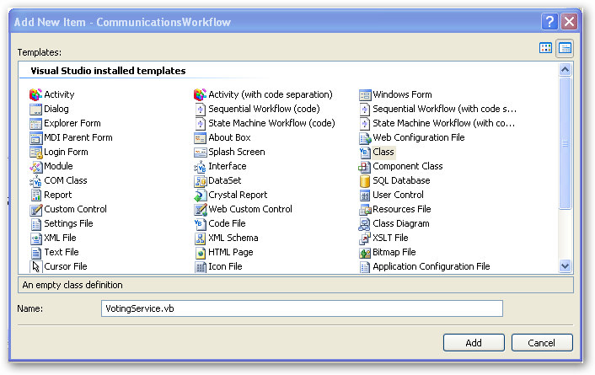

- VotingService.vb will be a blank file. Paste the following code or use the snippet to define the message, interface, and local service used by the workflow. The VotingEventArgs class defines the message passed between the service and the workflow and stores the instance id of the workflow as well as the alias of the person that is voting on the proposal. The IVotingService is an interface that defines how the service and workflow communicate. The workflow calls the service to create a new ballot using the CreateBallot method; the service raises the events into the workflow to indicate whether the person approved or rejected the proposal.

(Snippet: “Lab05 Task02 Exercise01 VotingService”)

Imports System
Imports System.Threading
Imports System.Workflow.ComponentModel
Imports System.Workflow.Runtime
Imports System.Workflow.Activities
Imports System.Windows.Forms

<Serializable()> _
Public Class VotingEventArgs
Inherits ExternalDataEventArgs

' Methods
Public Sub New(ByVal InstanceID As Guid, ByVal [alias] As String)
MyBase.New(InstanceID)
Me.Alias = [alias]
End Sub

' Properties
Public Property [Alias]() As String
Get
Return Me.anAlias
End Get
Set(ByVal value As String)
Me.anAlias = value
End Set
End Property

' Fields
Private anAlias As String
End Class

<ExternalDataExchange()> _
Public Interface IVotingService
' Events
Event ApproveProposal As EventHandler(Of VotingEventArgs)
Event RejectProposal As EventHandler(Of VotingEventArgs)

' Methods
Sub CreateBallot(ByVal [alias] As String)
End Interface

Public Class VotingService
Implements IVotingService

Public Event ApproveProposal(ByVal sender As Object, ByVal e As _
VotingEventArgs) Implements IVotingService.ApproveProposal
Public Event RejectProposal(ByVal sender As Object, ByVal e As _
VotingEventArgs) Implements IVotingService.RejectProposal

Public Sub CreateBallot(ByVal [alias] As String) Implements _
IVotingService.CreateBallot
Console.WriteLine(("Ballot created for " & [alias] & "."))
ThreadPool.QueueUserWorkItem(New WaitCallback(AddressOf _
Me.ShowVotingDialog), New _
VotingEventArgs(WorkflowEnvironment.WorkflowInstanceId, [alias]))
End Sub

Public Sub ShowVotingDialog(ByVal o As Object)

Dim args1 As VotingEventArgs = TryCast(o, VotingEventArgs)
Dim guid1 As Guid = args1.InstanceId
Dim text1 As String = args1.Alias
Dim result1 As DialogResult = _
MessageBox.Show(("Approve Proposal," & _
text1 & "?"), (text1 & " Ballot"), MessageBoxButtons.YesNo)
If (result1 = DialogResult.Yes) Then
If (Not Me.ApproveProposalEvent Is Nothing) Then
Me.ApproveProposalEvent.Invoke(Nothing, args1)
End If
ElseIf (Not Me.RejectProposalEvent Is Nothing) Then
Me.RejectProposalEvent.Invoke(Nothing, args1)
End If
End Sub

End Class

Task 3 – Define the Workflow

The workflow defines the voting logic for a proposal. For this workflow all proposals must be approved by Jim and the workflow manages when a ballot is created and completed. It creates a ballot for Jim and then waits for either an approval or rejection of the proposal.

- Rename the Workflow1.vb file to VotingWorkflow.vb by right clicking on the filename and choosing Rename.
- This will also rename the class within the file and you will see a dialog confirming this.

Note: Since we have not built the solution yet you may get a dialog stating the solution does not build in its current state, press Cancel to continue.

- Right click the VotingWorkflow.vb file and choose View Code. Copy and paste the highlighted code below into the VotingWorkflow class.

(Snippet: “Lab05 Exercise01 Task03 OnRejected”)

Public Class VotingWorkflow
Inherits SequentialWorkflowActivity

Private Sub OnRejected(ByVal sender As Object, ByVal e As _
ExternalDataEventArgs)
Console.WriteLine("Proposal Rejected")
End Sub
Private Sub OnApproved(ByVal sender As Object, ByVal e As _
ExternalDataEventArgs)
Console.WriteLine("Proposal Approved")
End Sub
End class

- Double click the VotingWorkflow.vb file to bring up the workflow designer.
- The ballot is created by calling the VotingService.CreateBallot method. To call a method on a local service from a workflow choose the CallExternalMethodActivity activity from the Toolbox and drag it on to the workflow.

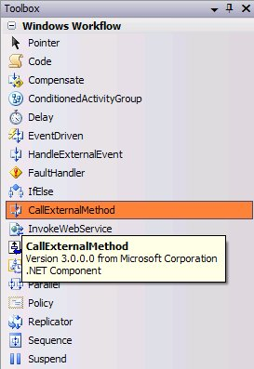

- Change the Name of the CallExternalMethodActivity activity from callExternalMethodActivity1 to CreateBallotForJim

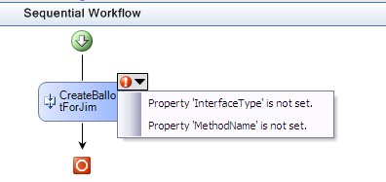

- Note, the activity’s validation logic is indicating we need to set several of the activity properties. To call a method on a local service we first need to set the interface property. Choose the ellipsis (…) next to InterfaceType and choose the IVotingService interface in the project.

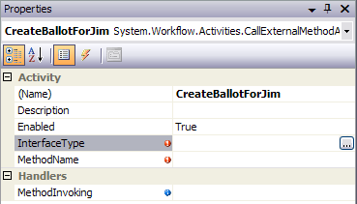

- Once an interface is selected, the method to invoke can be set. To do this, choose the CreateBallot method name for the MethodName property.

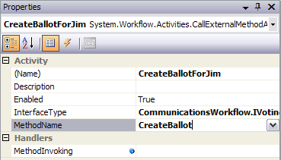

The CreateBallot method takes a single string parameter called alias. Type in Jim for the value of this property.

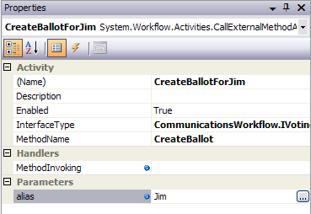

- The workflow now will create a ballot for Jim but it needs to get the response back. To do this, add a Listen activity after the CallExternalMethodActivity activity, name it WaitForJimResponse. Rename the left branch of the Listen activity to WaitForJimApproval and the right branch to WaitForJimRejection. The Listen activity will wait for a response from one inbound event before proceeding. In this workflow it will wait for the ballot response from Jim – i.e. to approve or reject the proposal.

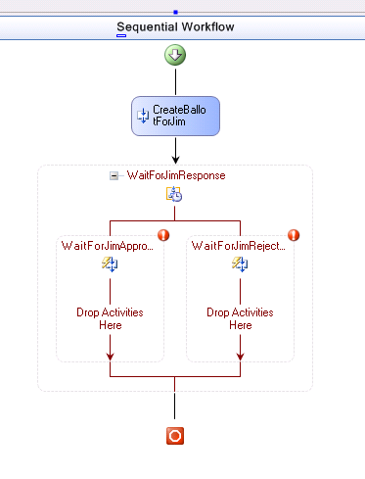

- The Listen activity needs to be configured with HandleExternalEvent activities. Add a HandleExternalEvent activity to the left branch by dragging and dropping the HandleExternalEvent activity to the left branch. Rename this HandleExternalEvent activity to JimApprove.

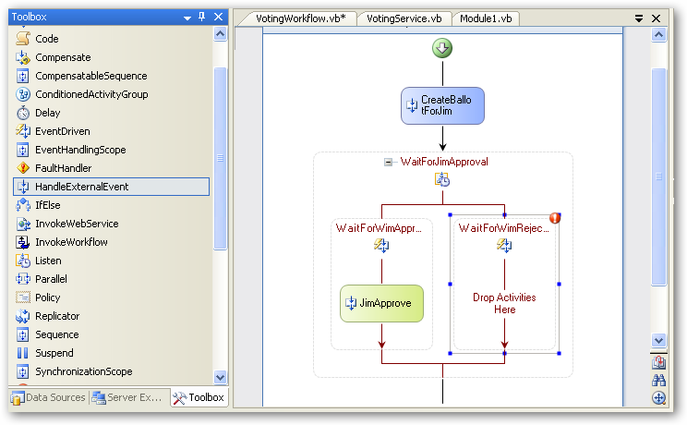

- In order for the workflow to get a message from a local service it must be bound to an event defined by an interface. This is done in a similar fashion as the CallExternalMethodActivity activity. Set the InterfaceType property to IVotingService and set the EventName to ApproveProposal by choosing ApproveProposal from the dropdown menu.

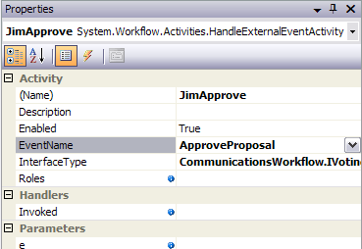

- For the e property select the property and click the ellipsis button next to it to bring up the activity binding interface. Select the Bind to a new member tab as shown below:

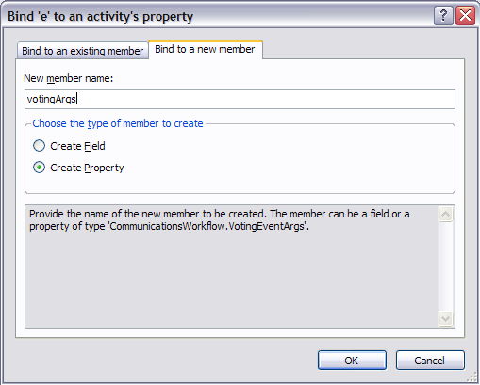
- Enter votingArgs in the New member name box and click OK.
- To view progress as the workflow executes we will have the OnApproved method called after an approval event is raised. To do this, select the Invoked parameter and type in OnApproved.
- Add a HandleExternalEvent activity to the right branch calling it JimReject. Set its InterfaceType to IVotingService and EventName to RejectProposal.
- Set the Invoked parameter to OnRejected, and set the e value to votingArgs by clicking on the ellipsis and using the activity binding interface to select VotingWorkflow.votingArgs as shown below:

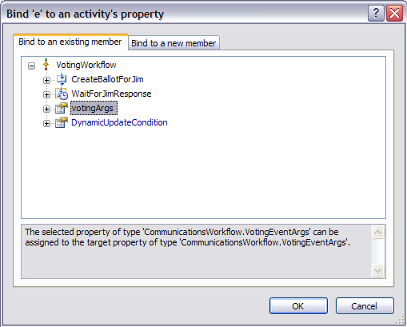
- Modify the OnApproved and OnRejected methods to include the name alias value.

Public Class VotingWorkflow
Inherits SequentialWorkflowActivity

Private Sub OnRejected(ByVal sender As Object, ByVal e As _
ExternalDataEventArgs)
Console.WriteLine(String.Format("Proposal Rejected by {0}", _
Me.votingArgs.Alias))
End Sub
Private Sub OnApproved(ByVal sender As Object, ByVal e As _
ExternalDataEventArgs)
Console.WriteLine(String.Format("Proposal Approved by {0}", _
Me.votingArgs.Alias))
End Sub
End class

- The completed Workflow should look like the following:

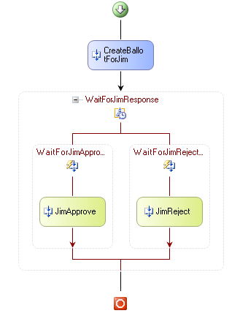

- Compile the solution and run.
- Approve the proposal when the MessageBox pops up.
- The output should look something like the following:

Workflow 272443dd-40fe-4806-aea1-aaa65c87641c created.
Ballot created for Jim.
Proposal Approved by Jim
Workflow 272443dd-40fe-4806-aea1-aaa65c87641c completed.
Press any key to exit...

Exercise 2 – Correlating Communication

In this exercise we will add an additional voter to the process. Both voters will get their ballots in parallel and both must vote on the proposal. The ballot creation and voting process is exactly the same as above and uses the same local service, interface, methods, and events thus it is necessary to correlate the responses between the local service and the workflow. For this workflow this means that the Jim responses from the local service go to Jim’s HandleExternalEvent activities and Alice’s response to Alice’s. This is done by decorating the interface with the correlation key information and adding a correlation reference object for each voter. This object is referenced by the corresponding CallExternalEvent and HandleExternalEvent activities.

Task 1 – Enabling the Interface for Correlation
- Add a new interface called IVotingServiceCorrelated in the VotingService.vb file just at the top of the namespace:

(Snippet: “Lab05 Exercise02 Task01 IVotingServiceCorrelated”)

<ExternalDataExchange(), CorrelationParameter("alias")> _
Public Interface IVotingServiceCorrelated

<CorrelationAlias("alias", "e.Alias")> _
Event ApproveProposal As EventHandler(Of VotingEventArgs)
<CorrelationAlias("alias", "e.Alias")> _
Event RejectProposal As EventHandler(Of VotingEventArgs)

' Methods
Sub CreateBallot(ByVal [alias] As String)
End Interface

- Change the inheritance of the VotingService so that it inherits from IVotingServiceCorrrelated.

Public Class VotingService
Implements IVotingServiceCorrelated
…
End class

- Modify the signature of ApproveProposal, RejectProposal, CreateBallot, to take the new interface name into account.
Public Event ApproveProposal(ByVal sender As Object, ByVal e As _
VotingEventArgs) Implements IVotingServiceCorrelated.ApproveProposal

Public Event RejectProposal(ByVal sender As Object, ByVal e As _
VotingEventArgs) Implements IVotingServiceCorrelated.RejectProposal

Public Sub CreateBallot(ByVal [alias] As String) Implements _
IVotingServiceCorrelated.CreateBallot

End Sub
- We will now have to update our workflow to reflect the change from using the IVotingService interface to the IVotingServiceCorrellated interface.
- In the workflow designer, select the CreateBallotForJim activity.
  - Change the InterfaceType to IVotingServiceCorrelated
  - Set the MethodName to CreateBallot
  - Set the alias to Jim
  - Set the CorrelationToken to correlationTokenForJim.

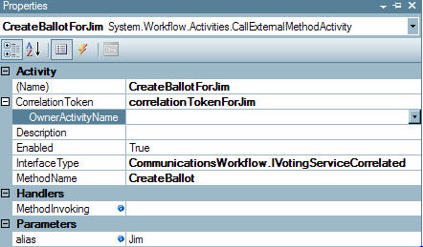

- Select the JimApprove activity
  - Change InterfaceType to IVotingServiceCorrelated.
  - Set EventName to ApproveProposal.
  - Set e to votingArgs by clicking the ellipsis and using the activity binding interface.
  - Set CorrelationToken to correlationTokenForJim using the drop down menu.

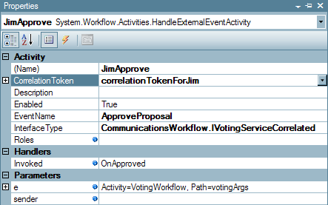

- Select the JimReject activity
  - Change the InterfaceType to IVotingServiceCorrelated
  - Set the EventName to RejectProposal
  - Set e to votingArgs by clicking the ellipsis and using the activity binding interface.
  - Set the CorrelationToken to correlationTokenForJim

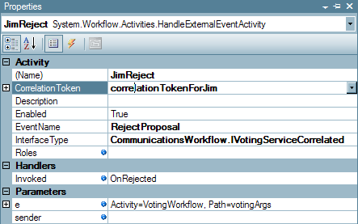

- You will notice the workflow designer has errors on each of the activities, ignore these for now as we will correct them shortly.

Task 2 – Modifying the Workflow with an Additional Voter

- In order to get both ballots for the proposal to execute in parallel, one for Jim and a second for Alice, we need to create parallel execution tracks for creating the ballot and listening for approval/rejection events. To do this first start by creating a Parallel activity at the root of the workflow. Rename the parallelActivity1 activity to SendBallots and the sequenceActivity1 activity in the parallel activity to JimSequence.

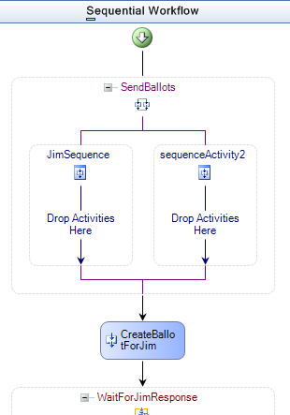

- Next, move the activities associated with Jim’s ballot into the left branch of the parallel activity by dragging and dropping the CallExternalMethod and Listen activities into the left branch.

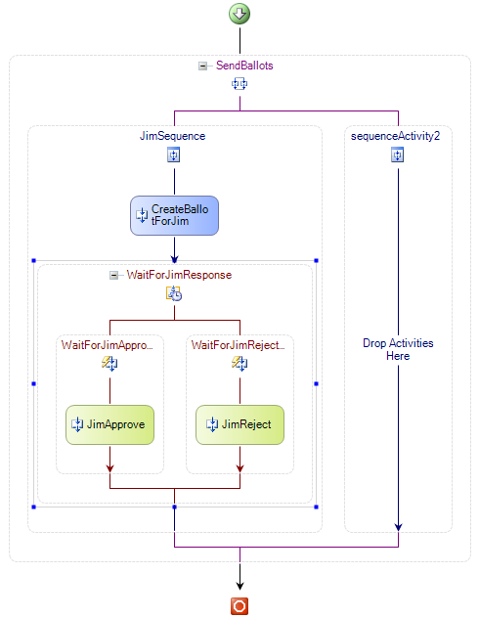

- For all three activities for Jim (CreateBallotForJim, JimApprove and JimReject) set the OwnerActivityName property (under CorrelationToken) to JimSequence.

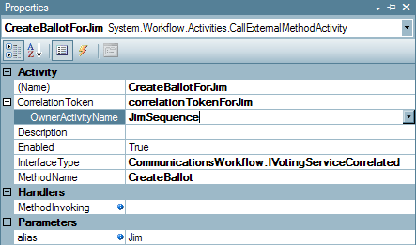

- Rename sequenceActivity2 to AliceSequence, who is the second voter.
- Drag on a CallExternalMethod and Listen activity from the Toolbox for Alice.
- Name the CallExternalMethod activity CreateBallotForAlice and the listen activity WaitForAliceResponse. Name the left sequence activity WaitForAliceApproval and the right sequence activity WaitForAliceRejection.
- For the CreateBallotForAlice activity
  - Set the InterfaceType to the IVotingServiceCorrelated interface
  - Set the MethodName to CreateBallot.
  - Set the alias parameter to Alice
  - Set the CorrelationToken to correlationTokenForAlice
  - Set the OwnerActivityName to AliceSequence from the drop-down list.
- Add two HandleExternalEvent activities for Alice in the Listen activity and name them AliceApprove and AliceReject.
- Also for each HandleExternalEvent activity
  - Set the InterfaceType to the IVotingServiceCorrelated interface
  - Set the EventName for each to ApproveProposal and RejectProposal
  - Set each e to votingArgs using the activity binding interface.
  - Set each CorrelationToken to correlationTokenForAlice.
  - Set the Invoked property for each to OnApproved and OnRejected.
- The completed workflow is below.

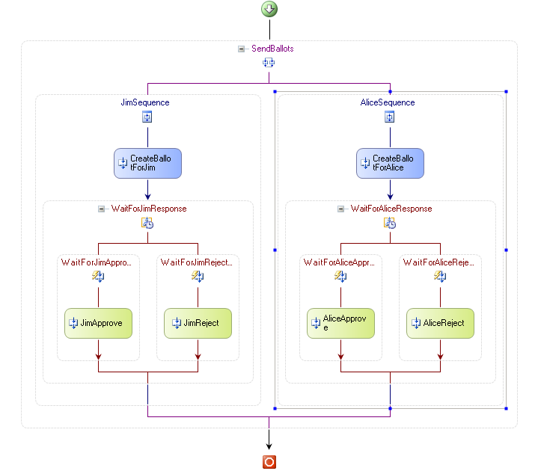

- Compile the solution and run.
- Use the MessageBoxes that pop up to accept or reject each proposal. You can test that the service is correctly separating the correlation tokens by approving one and rejecting the other.
- The output should look something like the following:

Workflow e9001953-0b08-4005-8105-47cd0b15a003 created.
Ballot created for Jim.
Ballot created for Alice.
Proposal Approved by Alice
Proposal Approved by Jim
Workflow e9001953-0b08-4005-8105-47cd0b15a003 completed.
Press any key to exit...

Exercise 3 – Roles and Security in Workflow

Windows Workflow Foundation supports the execution of activities based on the membership of a user in a given role. In this exercise, you will add role based authorization to a Workflow scenario. The Workflow scenario that is illustrated is the initiation of a purchase order. You will create a Workflow which requests a purchase order. The initiator will only be able to raise a purchase order if they are part of the Role that is configured for the HandleExternalEvent activity.

You will create a Workflow which has two activities. The first is a code activity which creates a Role of valid PO Initiators. The second activity is a HandleExternalEvent activity which is provided from the resources folder. The HandleExternalEvent activity is created with one interface to receive an event raised by the main program. The main program raises this event to request the initiation of a Purchase Order. You will have to ensure that the Role of valid PO Initiators includes the user name you specify.

If the user is part of the role then the Workflow completes successfully. If the user is not part of role then an exception is thrown by the HandleExternalEvent activity that is caught by the Workflow exception handler.

Task 1 – Create a new Workflow Project

- Copy the Exercise3 folder from the resources directory.
From source directory: C:\Windows Workflow Foundation\Labs\VB\Lab05\Resources\Exercise3
To destination directory: C:\Windows Workflow Foundation\Labs\VB\Lab05\Exercise3
- Open the solution file PurchaseOrderWorkflow.sln under C:\Windows Workflow Foundation\Labs\VB\Lab05\Exercise3
- The POInterface project defines the interface used for communicating information from the host. The HandleExternalEvent activity that is in the workflow uses the POInterface defined in this project

Task 2 – Build the workflow

- Build the solution so the POInterface and the PurchaseOrderWorkflow projects get built.
- Select the designer view by double-clicking PurchaseOrderWorkflow.vb in the Solution Explorer
- Add a Code activity to the workflow by dragging and dropping one from the Toolbox.
- Rename the codeActivity1 activity to SetupRoles in the Properties windows for this activity.
- Create an ExecuteCode handler called OnSetupRoles for the SetupRoles Code activity by typing OnSetupRoles for ExecuteCode property
- Select the designer view by double-clicking PurchaseOrderWorkflow.vb in the Solution Explorer.
- Add a HandleExternalEvent Activity to the workflow and drag it under the SetupRoles Activity of the workflow
- Select the properties windows of handleExternalEventActivity1 activity
- Set the properties as follows:
  - Set the Name property to InitiatePO
  - Set the InterfaceType property to IStartPurchaseOrder under the referenced POInterface assembly
  - Set the EventName property to InitiatePurchaseOrder by selecting from the drop-down list
  - Set the Roles property to poInitiators by clicking the ellipsis and using the activity binding interface to bind to poInitiators.
  - Set the Invoked Handler to OnInitiatePO by typing the value in. The handler OnInitiatePO will be created in PurchaseOrderWorkflow.vb file. Add the following line to this method:

Console.WriteLine("Purchase Order initiated successfully")

- Now your workflow should look like the following:

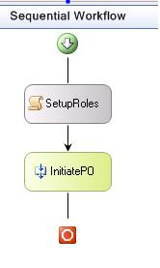

- Add the following code in the OnSetupRoles method (or insert using the code snippet).

(Snippet: “Lab05 Exercise03 Task02 POInitiators”)

WebWorkflowRole poInitiatorsRole = new WebWorkflowRole("Clerk")

// Add the role to the RoleCollection representing the POInitiators
poInitiators.Add(poInitiatorsRole)

Task 3 – Add an Exception Handler to workflow

- Select the workflow and right click View Fault Handlers to view the Fault Handlers.

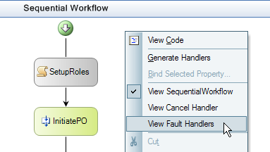

- Select and drag a Fault Handler into the workflow. It will be named as faultHandlerActivity1.

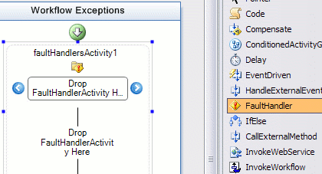

- Select the properties windows for the faultHandlerActivity1 and for the FaultType property for faultHandlerActivity1, specify System.Workflow.Activities.WorkflowAuthorizationException
- Select and drag a Code Activity into the faultHandlerActivity1. Rename the codeActivity1 activity that appears in Workflow Exceptions view to ExceptionHandlerCode
- Type in AuthExceptionHandler for the ExecuteCode property. This will create the code handler for this activity named as AuthExceptionHandler
- Add the following line to the method authExceptionHandler

Console.WriteLine("Exception message: {0}", _
faultHandlerActivity1.Fault.Message.ToString())

Task 4 – Building, Running and Validating the Roles Workflow

- Save the solution and build it.
- For this sample we are using the SQLProvider for role management, before running the example you must ensure that you have a configured database installed, we will be using the default database name ‘aspnetdb’. To automatically create and configure the database run the aspnet_regsql.exe tool found at:
\WINDOWS\Microsoft.NET\Framework\v2.0.50727\aspnet_regsql.exe
Install the configured database in localhost\SQLExpress and select the default settings, If you change the name of the database you will have to update the connection string found the app.config.
- Run the workflow by pressing F5.
- You should see the following:

Purchase Order initiated by: Amanda
Purchase Order initiated successfully

- Press Enter to exit the program.
- Modify the name “Amanda” in the SendPORequestMessage() method in Program.vb to “William”
- Build and run the workflow by pressing F5.

You should see the following:

Purchase Order initiated by: William
Exception message: Authorization failed for message received for event activity InitiatePO, from principal William

- Press Enter to exit the program.
The request failed for the user William because he was not a member of the authorized role.

Exercise 4 – Deferring a Long Running Operation to the Host

In this exercise we will use the workflow to raise an event to the host application to act as a long running process. The workflow will run parallel activities, one executing a short 5 second delay and the other executing a long running service, factoring the prime numbers found in 100000000. Once both parallel activities have completed the workflow will finish.

Task 1 – Create a new Workflow Project

- Open Visual Studio 2005 by going to the Start Menu | Programs | Microsoft Visual Studio 2005 | Microsoft Visual Studio 2005
- In Visual Studio 2005, select the File | New | Project menu command.
- Select Visual Basic | Workflow | Sequential Workflow Console Application. Change the Name to LongRunningWorkflow.
- Set the location C:\Windows Workflow Foundation\Labs\VB\Lab05.

Task 2 – Define our FactoringService

- Next we will define our interface, local service and custom ExternalDataEventArgs classes. Add a Code file to the project by right clicking the project and choosing Add | New Item
- Choose a Code File and name the file FactoringService.vb
- FactoringService.vb will be a blank file. Copy and paste the following using statements and namespace declaration into the FactoringService.vb file.

(Snippet : “Lab05 Exercise04 Task02 UsingStatements”)

Imports System
Imports System.Collections
Imports System.Collections.Generic
Imports System.Text
Imports System.Threading
Imports System.Workflow.Activities
Imports System.Workflow.Runtime

- Next we will add our custom ExternalDataEventArgs class which we will call PrimeFactoringEventArgs.

Copy and paste or use the code snippet provided to add our PrimeFactoringEventArgs class within the namespace declaration.

(Snippet : “Lab05 Exercise04 Task02 EventArgs”)

<Serializable()> _
Public Class PrimeFactoringEventArgs
Inherits ExternalDataEventArgs

Public Sub New(ByVal instanceId As Guid, ByVal primeCount As Integer)
MyBase.New(instanceId)
Me._primeCount = primeCount
End Sub

Public ReadOnly Property PrimeCount() As Integer
Get
Return Me._primeCount
End Get
End Property

Private _primeCount As Integer

End Class

- Now we will add our interface IPrimeFactoring, cut and paste the following code or use the code snippet provided to add IPrimeFactoring within the namespace declaration.

(Snippet: “Lab05 Exercise04 Task02 IPrimeFactoring”)

<ExternalDataExchange()> _
Public Interface IPrimeFactoring

Event FactoredPrimes As EventHandler(Of PrimeFactoringEventArgs)
Sub FactorPrimes()

End Interface

- Finally we will add our implementation of the IPrimeFactoring interface. This service will be called from the workflow and will begin factor prime numbers; once the process is complete it will raise an event to inform the workflow that it has completed. Cut and paste or use the code snippet provided to add the FactoringService class to FactoringService.vb, remember to include the class within the namespace declaration.

(Snippet: “Lab05 Exercise04 Task02 FactoringService”)

<Serializable()> _
Public Class FactoringService
Implements IPrimeFactoring

' Events
Public Event FactoredPrimes As EventHandler(Of PrimeFactoringEventArgs) _
Implements IPrimeFactoring.FactoredPrimes

Public Sub FactorPrimes() Implements IPrimeFactoring.FactorPrimes _
ThreadPool.QueueUserWorkItem(New WaitCallback(AddressOf _
Me.FactorPrimes), WorkflowEnvironment.WorkflowInstanceId)
End Sub

Private Sub FactorPrimes(ByVal instanceId As Object)

Console.WriteLine("Beginning Factoring Prime Numbers")
Dim time1 As DateTime = DateTime.Now
Dim num1 As Integer = 100000000
Dim array1 As New BitArray(num1, True)
Dim num2 As Integer = 2
Do While (num2 < num1)
If array1.Item(num2) Then
Dim num3 As Integer = (num2 * 2)
Do While (num3 < num1)
array1.Item(num3) = False
num3 = (num3 + num2)
Loop
End If
num2 += 1
Loop
Dim num4 As Integer = 0
num2 = 1
Do While (num2 < num1)
If array1.Item(num2) Then
num4 += 1
End If
num2 += 1
Loop
Dim span1 As TimeSpan = DateTime.Now.Subtract(time1)
Console.WriteLine(("Finished Factoring Prime Numbers (" & _
Math.Round(span1.TotalSeconds, 0) & " seconds)"))
If (Not Me.FactoredPrimesEvent Is Nothing) Then
Me.FactoredPrimesEvent.Invoke(Me, _
New PrimeFactoringEventArgs(DirectCast(instanceId, Guid), num4))
End If

End Sub

End Class

- Now that we have created our FactoringService, save the project and build the new service.

Task 3 – Create a Workflow

- Open the Solution Explorer and double click the file Module1.vb.
- Add a using statement to the top of the Module1.vb file
imports System.Workflow.Activities

- Add the highlighted code within the Main method. Cut and paste or use the code snippet provided for the first section and add the line at the end manually.

(Snippet: “Lab05 Exercise04 Task03 MainMethod”)

Shared Sub Main()

Using workflowRuntime As New WorkflowRuntime()

AddHandler workflowRuntime.WorkflowCompleted, AddressOf _
OnWorkflowCompleted
AddHandler workflowRuntime.WorkflowTerminated, AddressOf _
OnWorkflowTerminated

Dim dataService As ExternalDataExchangeService = New _
ExternalDataExchangeService()
workflowRuntime.AddService(dataService)

dataService.AddService(New FactoringService())

Dim workflowInstance As WorkflowInstance
workflowInstance = _
workflowRuntime.CreateWorkflow(GetType(Workflow1))
workflowInstance.Start()
WaitHandle.WaitOne()
Console.WriteLine("press any key to continue")
Console.ReadLine()

End Using

End Sub

The code is essentially the same although if you notice the three lines of highlighted code above we added an ExternalDataExchangeService and our FactoringService into the worklow.
- Open the Solution Explorer and double click on the file named Workflow1.vb to open the workflow in design mode.
- Our workflow is going to branch into two paths, one path will invoke our service which we created in task1 and begin the time consuming task of factoring prime numbers, the second path will simply delay for 5 seconds. Once both paths have completed the workflow will be complete. As both paths will be running simultaneously we will use the Parallel activity, open the Toolbox and drag and drop a Parallel activity onto the workflow.
- Click on the section named sequenceActivity1 and, using the properties window, set the Name property to factoringSequence. Similarly rename sequenceActivity2 to delaySequence.
- Your Workflow should now look similar to this

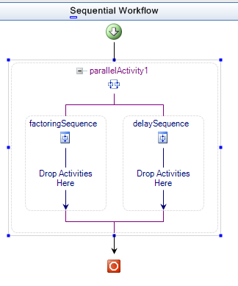

- Now we will add some activities to utilize our factoring service. Drag and drop a CallExternalMethod activity into our factoringSequence.
- Change the Name of the CallExternalMethodActivity activity from callExternalMethodActivity1 to BeginFactoring.
- Set the InterfaceType to IPrimeFactoring by clicking the ellipsis (…) next to InterfaceType and choose the IPrimeFactoring interface in the project.
- Using the drop down menu, set the MethodName to FactorPrimes.

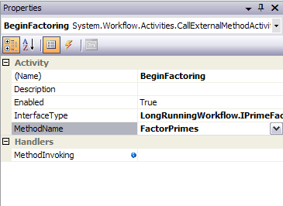

- Now we need to handle the event raised by the FactoringService when it has completed Factoring the prime numbers. Drag and drop a HandleExternalEvent activity onto the workflow just below the BeginFactoring activity and still within the factoringSequence.
- Rename handleExternalEventActivity1 to FactoringComplete and set the InterfaceType to IPrimeFactoring.
- Using the drop down menu, set the EventName to FactoredPrimes.

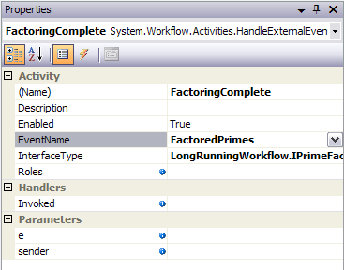

- Your workflow should now look similar to this:

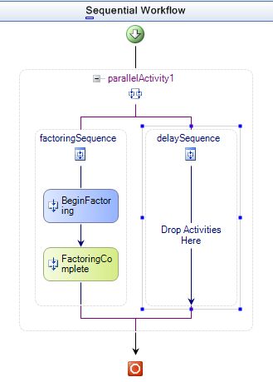

- Next we will create the delaySequence, drag and drop a Delay activity from the Toolbox into the delaySequence.
- Set the TimeoutDuration property of delayActivity1 to 5 seconds.
- Save the workflow and build the project.
- For demonstration purposes we will add a number of Code activities to our workflow so we can watch the progress in the console.
- Right click the file Workflow1.vb in the Solution Explorer and select View Code.
- Cut and paste or use the code snippet provided to add the following 4 event handlers to the Workflow1 class

(Snippet: “Lab05 Exercise04 Task03 EventHandlers”)

Private Sub BeforeDelay_Execute(ByVal sender As Object, _
ByVal e As EventArgs)
Console.WriteLine("Beginning Delay")
End Sub

Private Sub AfterDelay_Execute(ByVal sender As Object, _
ByVal e As EventArgs)
Console.WriteLine(String.Format("Finished Delay ({0} seconds)", _
Me.delayActivity1.TimeoutDuration.Seconds))
End Sub

Private Sub BeforeBranch_Execute(ByVal sender As Object, _
ByVal e As EventArgs)
Console.WriteLine("Beginning Branch")
End Sub

Private Sub AfterBranch_Execute(ByVal sender As Object, _
ByVal e As EventArgs)
Console.WriteLine("Finished Branch")
End Sub

- Press SHIFT + F7 to switch to design mode and we will add a code activity for each of these.
- Drag and drop a Code activity onto your workflow just before parallelActivity1, rename the activity from codeActivity1 to BeforeBranch.
- In the ExecuteCode property use the drop down menu and select BeforeBranch_Execute event handler.

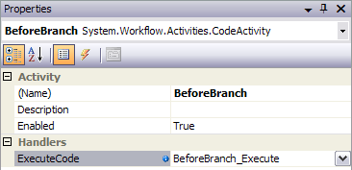

- Drag and drop a second Code activity onto your workflow just before delayActivity1 within the delaySequence, rename the activity from codeActivity1 to BeforeDelay.
- Set the ExecuteCode property to BeforeDelay_Execute.

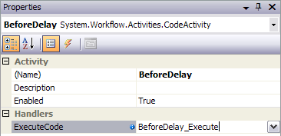

- Drag and drop a third Code activity onto your workflow just after delayActivity1 within the delaySequence, rename the activity from codeActivity1 to AfterDelay.
- Set the ExecuteCode property to AfterDelay_Execute.

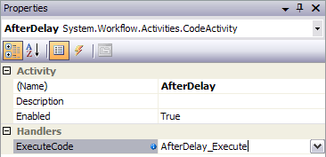

- Finally, drag and drop a Code activity onto your workflow just after parallelActivity1, rename the activity from codeActivity1 to AfterBranch.
- Set the ExecuteCode property to AfterBranch_Execute.

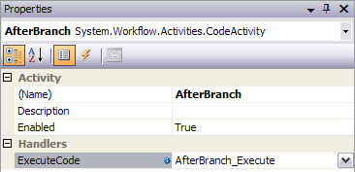

- Your finished Workflow should look similar to this:

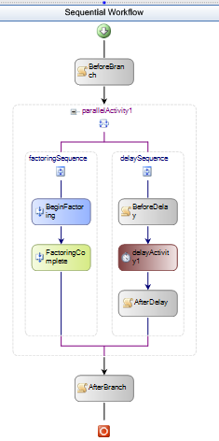

- Save and run the Workflow by pressing F5, you should see the progress of your workflow in the console as it executes

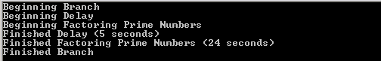

- Press Enter to exit the program.

As you can see, the long running process was carried out by the host application while the workflow was idled. We could, of course, add a PersistenceService to our Host and allow the runtime to persist out the workflow while the long running process was taking place. In this way we can potentially support processes that may span several hours, days or even weeks.

Lab Summary
The objective of this lab was to introduce Windows Workflow Foundation communication with the host application using a local service. A local service is a way to provide host application functionality to a workflow. Communication to a workflow is accomplished using events raised by the local service; a local service is called by a workflow via methods.
During this lab, you should have:
- Created a simple local service that exposes a method in which it does some work and also publishes an event which it raises when its work is complete.
- Created a more complex workflow that uses correlated messaging to route message to the appropriate activity within a workflow.
- Added role based authorization and security to a Workflow scenario
- Created a simple Workflow that actions a long running process

